25th October 2017

My first port of call for the day is to ty and get things working with the schaffer problem.

My steps of checking are:

Check all objective function values are not stupid. I can confirm the values coming out are fairly reasonable.

Check what the pareto front size is looking like.

So, the Pareto front seems to be very large, but then findParetoFront seems to mess it up, which is very strange. I’m gonna check the results without this, and then see what happens. If I plot it and it looks good, I’m fairly happy, and can solve this small problem. The point is whether I am actually getting to the stage of having good solutions.

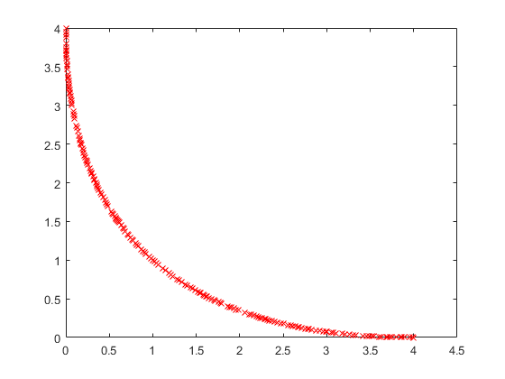
This is my multi-objective optimisation implementation.

This is the ground truth solution:

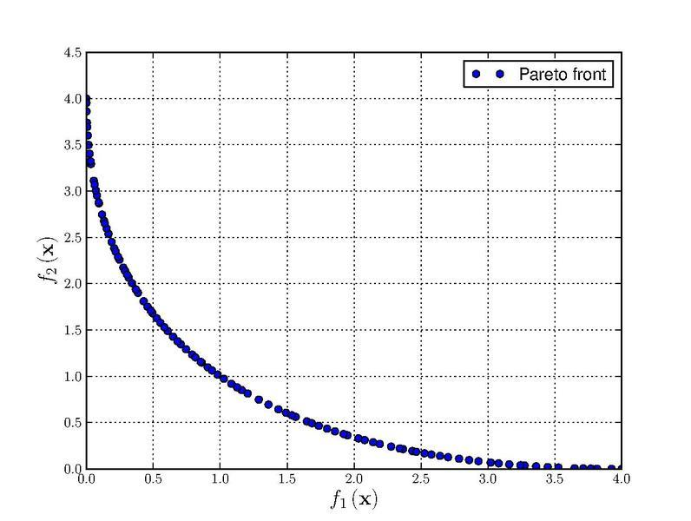

So basically, all I have to do is sort out the very end of the algorithm, and then I am good to go on my actual problem.

So for the end of the algorithm, what I now do is take the solutions in P which have a front of 0. This is a somewhat reasonable option. However, I may have a bigger issue, in that, when I allow the initialization of P before the first generateOffspring, then I get a bad alloc after iteration 19. This seems to suggest i’d be running out of memory, but I am unsure.

One thing I have found out, is that I should probably pass my X matrix by const reference in order to minimise memory usage. Other than that, things seem to work OK now.

All I need to try now, is with my objective functions. But that can be done late, since right now, I am actually fairly happy :)

If things seem to be really slow, it may be worth me parallelising the objective function calculations.

As of 4pm, problems I have involve the running time and memory usage. The system happily breaks if it wants to, which is not ideal in any sense. It also doesn’t appear to be working very well with what I have so far, but this is somewhat expected I’d say.

If I assume the population size isn’t a big deal, it seems I can run with more iterations. The problem is mainly memory usage/running time (need to look at the gpu), and the objective functions themselves.

I thought I’d try with and without some of my objective functions, to see the difference made

It didn’t really make a difference. Therefore I’m gonna stop for today, and think about what I need to do tomorrow.

